**How to create a Facebook App:**

1. Login to the Facebook developer account ( <http://developer.facebook.com/> )
2. Add a New App

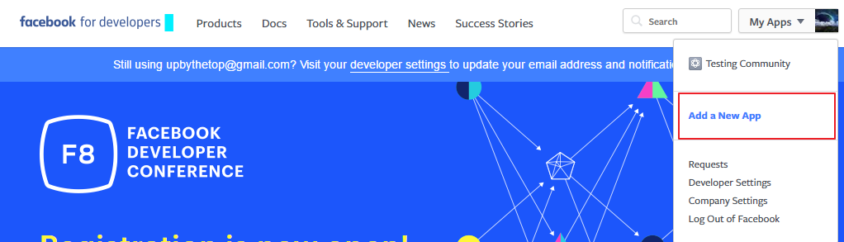

1. A popup will appear where you need to provide the “Display name”, and choose Category

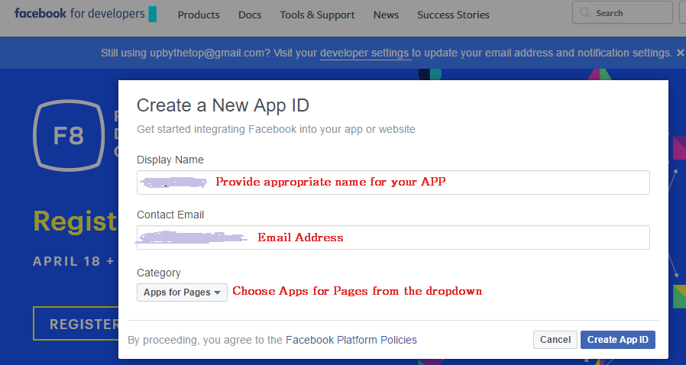

1. Now after you created an APP then go to the Dashboard where you can see the “APP ID” & “APP SECRET” key. Copy and kept it save in some editor
2. Now Go to Settings and fill the “App Domains”, “Privacy Policy Url”, “Terms of Service URL”, “APP icon”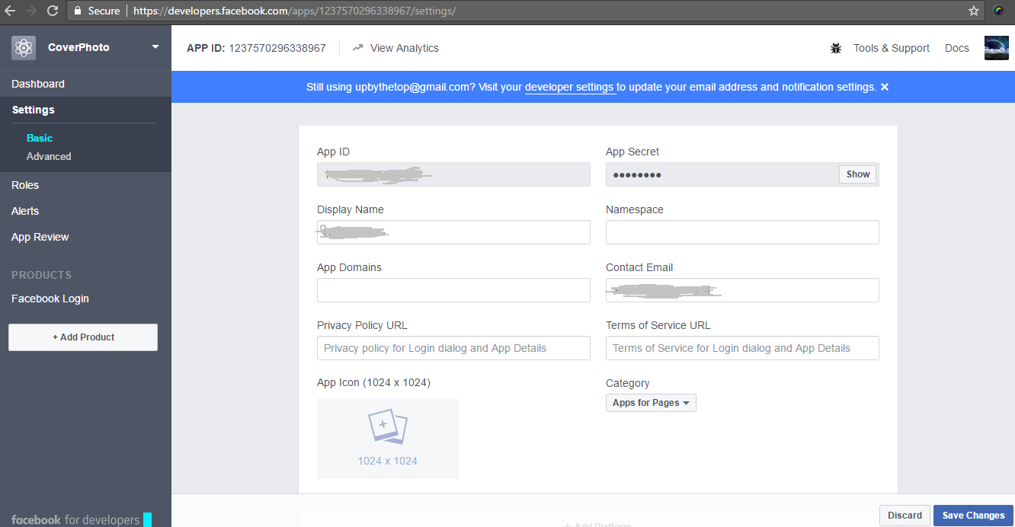
3. Now click on the “Add Platform” then a popup appears as follow and choose “Website”

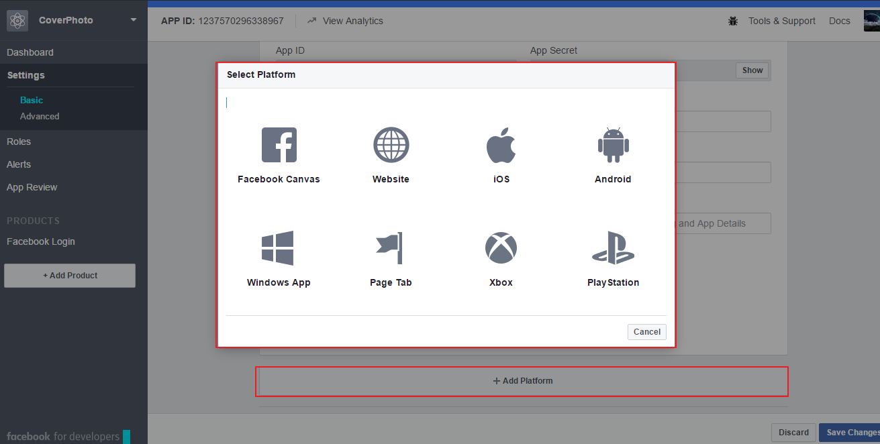

1. then you need to add your Site URL
2. Now Go to “App Review” and make your App to public by toggle the button on the top of the page. Click on ‘Start Submission’ button in the bottom right corner of the page. A popup will appear.

* Select "publish_actions" permission and click "Add Item". Then your "publish_actions" is included in this submission using the FB API
* Now you need add Notes for publish_actions by clicking "view notes" then a popup appear where you need to fill and upload screencast video as like in  
   (<http://screencast-o-matic.com/watch/cbeihL6UHz> )
* Save. And add “user_photos” similarly as “publish_actions” and add notes on this item as wells
* Now click the “Submit For Review” button

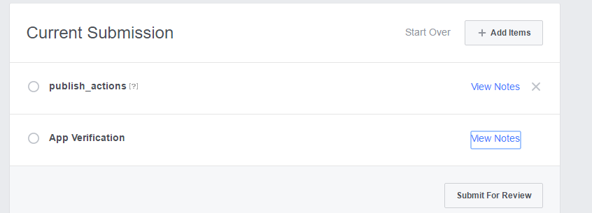

* On average, submissions will be reviewed within 5 business days.

**How to create** **video using Screencast-o-Matic**

- <https://www.youtube.com/watch?v=tQeky1RG0jU>